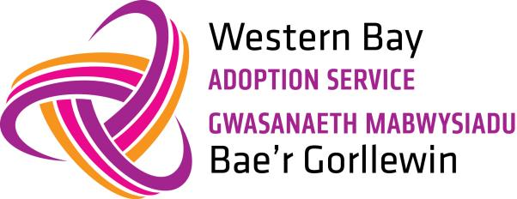 | Post adoption support

Support for adopters
We have a team of specialist social workers dedicated to post adoption support.
Adoption can be challenging, but we can help you. We can also work with you to ensure your child has a life story book with information about adoption, and why they’ve been adopted.
You can contact us about:
- Western Bay support groups and advice sessions
- assessment of adoption support needs
- details of specialist services and how to access them
- accessing therapeutic services
- supporting you and your child with contact with their birth family
- training and workshops
- support for children who have experienced loss and trauma
- advice for adoptive parents moving to a different local authority
- a buddy system where you can be put in touch with other adopters for peer support

Support for adopted children
We know that being an adopted child may not always be easy and there might be things that you don’t understand or would like help with. But there is always someone you can talk to.
These are some of things that you might want help with:
- Information about your birth family.
- Understanding why you were adopted.
- Arranging to keep in touch with brothers and sisters, your birth mum or dad and other relatives and friends.
- Understanding your feelings – sometimes you might feel angry or sad or just not know how you feel.
- Coping with school, some children who are adopted find school very difficult and need extra help.
- Opportunity to meet with other adopted children
If you ask your parents about any of these things they might be able to help you themselves or they may know where to go to find out more. Your parents can also contact the Adoption Support Team in Western Bay to help answer these questions.
The Adoption Support Team has people who know a lot about adoption and who work with adopted children and young people and their families.
If you would like to talk to someone about any of these things, you or your parents can contact the Adoption Support Team on 0300 365 2222

Support for birth relatives of adopted children
Contact between an adopted child with their birth parents can help them understand more about their background and identity.
Arrangements for contact are agreed in writing before the child is adopted. This includes how often contact is made, and whether it is direct (in person) or indirect (by letter through our ‘letterbox’ service).
We can provide support for birth relatives wanting help with contact arrangements, counselling, or intermediary services.

Counselling
Western Bay Adoption Service do not offer a counselling service but can support you to locate a service that is suitable for you.

Will my child be able to find me after adoption?
From the age of 18 your child can ask for a copy of their original birth certificate, which will show:
- their original name
- the name of their birth mother
- (possibly) the name of their birth father
- their address when their birth was registered
The Adoption Contact Register can also help an adopted child get in touch with you.

Finding birth records for adopted adults
We provide support for adopted adults in Western Bay looking for their birth records and information about their birth family.
We can help you if:
- you're over 18 years of age
- you live in Bridgend, Neath Port Talbot or Swansea
- we have your adoption records
Call 0300 365 2222 to ask about how to proceed.

Adoption from care
Children adopted from care can sometimes have ongoing needs, which we can help with. We will assess your support needs and advise you on the services available to you.
Adoptive parents can have access to:
- a copy of your child’s CARB report
- a summary of your child’s health from Western Bay’s Adoption’s medical advisor
- workshops to help you use or build a ‘life story’ book of your child’s early life
- an assessment of your child’s adoption support needs

Support for other authorities
Our adoption support services can also offer advice to other local authorities about:
- our adoption support services
- assessments of need for support
- availability of local services
- how to work between other adoption agencies

Comments and complaints
If you're unhappy with the service we've provided, you can make a complaint. Please ask for the complaint leaflet for the local authority in which you live.

