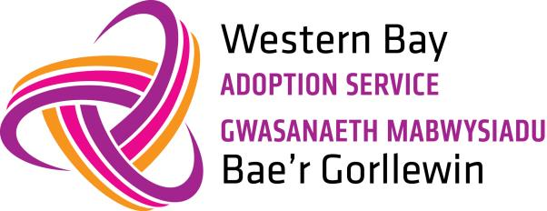 | The Adoption Letterbox System  Information for: Birth Family Members

What is Letterbox?
The Letterbox system is a two way process whereby adoptive and birth families are able to send and receive information about a child who has been adopted. For children this two way information is a vital link between both their birth and adoptive family and helps to maintain important links.

The Letterbox is voluntary; it is not a legal agreement…

Why have Letterbox?
It is very helpful for adopted children to have some knowledge of their birth family and their back ground, as the information that adopted parents are given at the time of the adoption quickly becomes out of date.
Letterbox helps the children to see that they are not forgotten by their birth family and to help them in the future if they have any questions about their birth family.

Letterbox lets you share your news, interests and stories with a special child…

What are the benefits of Letterbox contact?
Exchanging information allows adopted children to learn more about their birth family. To gain more details about their interests, likes and dislikes and for them to know they are thought about by their family of birth.

The Letterbox system lets you hear news and pass on news…

When does it start?
Those involved will be asked to sign a Letterbox Agreement in readiness for a child being placed in an adoptive family. Letterbox continues until the child is 18 or beyond in some circumstances. The prospective adopters are asked to send in a settling in report early on, which will be shared with you once we receive it. The Letterbox Co-ordinator can give help and advice to anyone who would like it.

What can I send via the Letterbox system?
This will be agreed and listed in the Letterbox Agreement and might include the following:
- An annual letter from you to the child.
- Cards for special occasions, such as Birthdays and Christmas.
(Please note no card larger than A4 and not saying son/daughter etc.)
- Occasionally the decision is made that a letter cannot be sent on, because it may be written in a way that may upset or confuse the child. In this case we will contact you and support you to write a more appropriate letter.
! The Letterbox scheme cannot cope with the exchange of presents, vouchers or money. We realise some people will be disappointed by this, and hope they will understand.

What can you receive via the Letterbox system?

- An annual letter about your child’s development and situation.
! It is highly unlikely that you will receive up to-date photos of your child. We realise this will be very disappointing for you however we must be very firm in this regard for security reasons.

How do I get my Letterbox contact?

Your Letterbox Agreement will tell you what month your contact is due. It is important that everyone involved in letterbox keeps Western Bay Adoption Service up to date with changes of address and telephone numbers. We do not send out any letterbox materials unless we have an up to date address.

What should I write?
You can write about -
- What’s happening in your everyday life; interest, hobbies.
- News about events in the family.
- News of any brothers and sisters or other relatives who the child has a relationship too.
- That you are pleased to hear your child/children are doing well.
- Include any questions you might have.
Any changes?
Please contact us if…
- Your address changes.
- Your personal circumstances change.
- You no longer want to partake in the system.
We will contact you if…
- Your child no longer wishes their adopters to continue sending letters. We will support you with this.
- If we have any changes that may need to be made to the arrangements.
Additional information

You will have a named social worker taking responsibility for your Letterbox contact.

